Web programming lab 11

23BCE1016 Tarun Chebolu

## Question2

## Code

## Question3

## Code

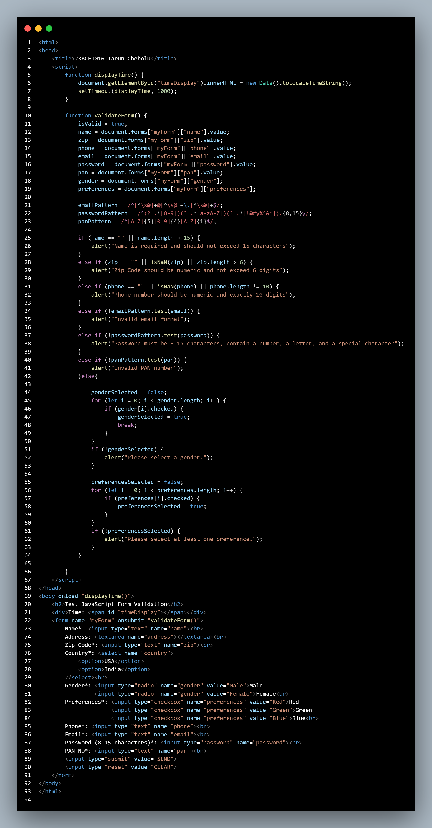

## Output

